Health & Wellness Jamboree  WHEN  October 29th  8:00 am to Noon  WHERE  Wilson County Fairgrounds  945 East Baddour Parkway Education Building C Lebanon, TN. 37088  Easy Access and Free Parking  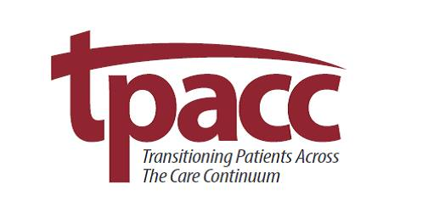  Brought to you by:  Brought |  |  |  | Free Health Screenings & Local Resources  Exhibitors  University Medical Center  Summit Hospital Cookeville Regional  The Renewal Center at Riverview  Pharmacare Pharmacy- flu shots  Quality Mobile X-Ray-Bone Density and Carotid Artery Screenings  Cumberland Mental Health  Blood Pressure Checks  Mental Health Screenings  Virtual Dementia Tour  Elder Law Attorney  DCI Dialysis  Gentiva Home Health & Hospice  Home Health of Middle TN.  Cookville Regional Medical Home Health  Willowbrook Home Health  Whole Care Connections  Senior Helpers  Home Instead  Council On Aging  Mid-Cumberland & Upper Cumberland Transport  Quality Rehab & Health  First Call Ambulance  Neuhause Foot & Ankle  Vanderbilt Dementia Research Studies  Q Source  Connect2Docs  Life Care of Antioch  NHC Home Care  Many others!

